**TITLE:** *(150 characters maximum)*

An open-source EEGLAB plugin for jointly analyzing EEG and cardiovascular signals.

**AUTHORS AND AFFILIATIONS:**

Cedric Cannard1,2, Helane Wahbeh2, Arnaud Delorme1,2,3

1Centre de Recherche Cerveau et Cognition (CerCo), CNRS, Toulouse III University, France

2Institute of Noetic Sciences (IONS), Novato, California, USA.

3Swartz Center of Computational Neuroscience (SCCN), INC, UCSD, La Jolla, USA

Corresponding Author:

Cedric Cannard

ccannard@noetic.org

Tel: (510)-326-1734

Email Addresses of Co-authors**:**

Helane Wahbeh hwahbeh@noetic.org

Arnaud Delorme adelorme@ucsd.edu

**KEYWORDS:** *(6 minimum, 12 maximum)*

EEGLAB, EEG, ECG, PPG, HRV, features, hearbeat-event

**SUMMARY:** *(10-word minimum, 50-word maximum)*

The summary should clearly state the goal of the protocol. It may include a general description of the method and its applications. This description should focus on the protocol, not the results obtained by the method.

**ABSTRACT:** *(150-word minimum, 300-word maximum)*

The abstract should focus on the method being presented rather than the results of a specific experiment. Include a statement about the purpose of the method. A more detailed overview of the method and a summary of its advantages, limitations, and applications is appropriate. Please focus on the general types of results acquired. Do not include references here.

The interaction between the cortical and cardiovascular systems has been the subject of increasing interest, as it can capture useful information about the coupling of brain and cardiovascular function. These systems are often analyzed jointly using neuroimaging methods that are invasive (PET) or very costly (MEG, fMRI).

However, analyzing the interaction between these multidimensional data can be challenging due to their complex or noisy nature, the lack of tools to easily analyze them jointly, and the lack of standardized methods (choice of data cleaning, parameters, etc.).

We present the BrainBeats toolbox to address these limitations, an open-source EEGLAB plugin for jointly processing and analyzing electroencephalography (EEG) and electrocardiography/photoplethysmography (ECG/PPG) signals.

EEG and ECG/PPG are non-invasive, low-cost, and highly mobile techniques for monitoring brain and cardiovascular activity. They offer distinct advantages over other neuroimaging methods (e.g.,) including lower cost, portability, and ability to collect data in real-world settings. Existing tools for jointly analyzing these biosignals often require a high level of technical expertise and may not provide all of the necessary features for studying the interaction between these signals. Moreover, many existing tools are not open-source, limiting their accessibility, and a consensus towards clear signal processing guidelines is still in development and reproducibility. The proposed toolbox addresses these limitations by providing a comprehensive set of signal processing functions, implementing the latest guidelines as its default parameters, and three main functions: 1) feature-based for continuous data for assessing associations between various features extracted from EEG and HRV signals (time, frequency, and nonlinear features); 2) event-related for epoched data (EEG-ECG coherence, heartbeat-evoked potentials in time, frequency, and time-frequency domains); 3) EEG signal processing (extracts heart components from EEG signals using ICA). Robust statistics are implemented for assessing relationships between these time series at the individual level (e.g., permutation statistics, corrections for type 1 error). Linear and nonlinear features are provided to better capture complex, bidirectional interactions between that take place between the cardiovascular, subcortical, and cortical systems. Additionally, the toolbox can be used simply for extracting heart components from the EEG data using independent component analysis (ICA). This open-source toolbox should provide a valuable resource for researchers and clinicians interested in studying the relationship between the brain and cardiovascular activity and can be easily adapted and extended to meet specific research needs.

**INTRODUCTION:** *(150-word minimum, 1500-word maximum, 2-paragraph minimum)*

* Purpose of this method

The purpose of this method is to ease the investigation of relationships between the brain and the heart by facilitating the joint analysis of electroencephalography (EEG) and cardiovascular signals, namely electrocardiography (ECG) and photoplethysmography (PPG), while implanting the latest guidelines from experts in this field. This tool addresses limitations from existing tools and is made open source to facilitate accessibility and reproducibility in the field. The proposed toolbox should serve as a valuable resource for researchers and clinicians interested in removing cardiac artifacts from EEG signals, in extracting features from EEG and ECG/PPG signals, or in studying the relationship between brain and cardiovascular activity. Ultimately, this toolbox aims to pave the way for more in-depth investigations into the complex interplay between the brain and heart systems.

* The rationale behind the development and/or use of this method + context of the method in the wider body of published literature

**Reductionist vs. multimodal approaches**

For a long time, the reductionist approach has dominated scientific inquiry in the field of human physiology and cognition. This approach involved dissecting complex bodily and mental processes into smaller, more manageable components, allowing researchers to focus on individual systems in isolation. This strategy arose due to the immense challenge of studying the intricate and interconnected nature of the human body and mind (von Bertalanffy, 1968). Reductionism has been instrumental in understanding individual subsystems in isolation, such as elucidating the role of ion channels and action potentials for neural (Hodgkin & Huxley, 1952) and cardiac (Bean et al., 1984) communication. However, a large gap remains in our understanding of how these isolated systems interact together on a larger spatial and temporal scale. Thanks to recent advances in technology, a more integrative approach is now gaining interest. Innovations in hardware, signal processing, data storage, and computing capabilities have enabled researchers to collect and analyze electrophysiological signals from different bodily systems simultaneously (e.g., heart, brain, skin, etc.; Jiang et al. 2019; Insel et al., 2017; Kappenman & Luck, 2010). This integrative – or multimodal – approach will pave the way for a more comprehensive understanding of human physiology, cognition, pathology, and consciousness (Bunge, 2003; Fuchs, 2018; Thayer & Lane, 2009). Consequently, this multimodal approach is now considered an essential component of modern research, complementing traditional reductionist methods and offering novel insights into the synergistic mechanisms governing the human body and mind.

**Heart-brain research with fMRI and PET**

Studying the intricate relationship between the brain and the heart can yield valuable insights into the underlying physiology and anatomy of the human body, ultimately leading to the development of novel diagnostic and therapeutic tools. The relationship between the heart and the brain has been studied via neuroimaging methods such as functional magnetic resonance imaging (fMRI) and positron emission tomography (PET). Using these tools, researchers highlighted some brain regions associated with cardiovascular control (e.g., manipulation of heart rate and blood pressure; Critchley 2000; Napadow 2008), showed the influence of heart rate on the BOLD signal (Chang et al., 2009; Shmueli 2007), or identified potential brain-body pathways contributing to coronary heart disease (i.e., stress-evoked blood pressure; Gianaros 2009).

**EEG, ECG, and PPG**

While these studies have significantly advanced our understanding of the complex interplay between the central nervous system (CNS) and cardiovascular function, these neuroimaging techniques are expensive, have limited availability, and are confined to controlled laboratory settings, which restricts their practicality for real-world and large-scale applications. In contrast, EEG and ECG/PPG are more affordable and portable tools that offer the potential for studying brain-heart interactions in more diverse settings and populations or over longer periods of time, providing new opportunities for investigating the dynamic relationship between brain and heart function. ECG measures the electrical signals generated by the heart when it contracts and relaxes via the placement of electrodes on the skin (usually on the chest, arms, or legs). PPG measures blood volume changes in the microvascular tissues by using a light source (e.g., LED) and a photodetector placed on the skin (commonly on a fingertip, earlobe, or forehead). Since blood absorbs more light than the surrounding tissue, the PPG signal can be used to estimate blood flow and pulse rate. Both methods provide valuable information about the cardiovascular function, but they serve different purposes and offer distinct types of data. As such, the use of EEG and ECG/PPG holds great promise for advancing our understanding of the physiological, cognitive, and emotional processes underlying brain-heart interactions and their implications for human health and well-being. Similar to ECG, EEG records the electrical fields generated by synchronized activity of thousands of cortical neurons by placing electrodes on the scalp.

**The 2 approaches to jointly analyzing EEG and cardiovascular signals**

There are two main approaches to study interactions between EEG and cardiovascular signals:

1. Event-related: each heartbeat is marked in the EEG time series to examine with high temporal accuracy the cortical activity processing cardiac signals (Schandry 1981; Pollatos 2005; Montoya 1993; Park & Tallon-Baudry 2014; Couto 2015; Jiang et al. 2019; Dirlich et al., 1998). This method is termed heartbeat-evoked potentials (HEP) and is similar to traditional event-related potential (ERP) studies, which required the two time series to be time-locked, but the events are heartbeats as opposed to stimuli.
2. Feature-based: using continuous data, this approach extracts features from the EEG signals and from the cardiovascular signals and examines associations between them. Cardiovascular features are typically heart-rate variability (HRV) measures in the time, frequency, or nonlinear domains. This has been done with ECG (Thayer et al. 2012; Mather 2018; Kemp 2013) and PPG to a lesser extent (Khosrow-Khavar 2014). This approach provides trait information that can be used for making medical forecasting or classification (e.g., mental or physical health) and finding more general associations relative to HEP that focus on mechanisms at millisecond accuracy.

The advantages over alternative methods with references to relevant studies

While some tools exist to process cardiovascular and EEG (e.g., EEGLAB, Fieldtrip, Brainstorm) signals separately, none is currently available for jointly analyzing them. Furthermore, the tools available to process cardiovascular signals:

* require expensive license purchase and do not allow processing large datasets in batch via command line (Kubios);
* or require advanced programming skills by not providing a graphical user interface (GUI; Physionet Cardiovascular Signal toolbox; [Vest et al. 2019](https://www.ncbi.nlm.nih.gov/pmc/articles/PMC6442742/pdf/nihms-1509712.pdf)).

To our knowledge, three open-source MATLAB toolboxes exist to support HEP analysis with a GUI. The ecg-kit ([REF](https://github.com/marianux/ecg-kit); Demski and Soria, 2016), the HEPLAB EEGLAB plugin ([REF](https://github.com/perakakis/HEPLAB)), and the CARE-rCortex EEGLAB plugin ([Grosselin et al. 2018](https://www.sciencedirect.com/science/article/abs/pii/S0165027018302474)). While HEPLAB and ecg-kit facilitate HEP analysis by detecting heartbeats and marking them in the EEG signals, they do not provide statistical tools for analysis, and are limited to the time domain (i.e., ERP). The CARE-rCortex addressed these issues by supporting both ECG and respiratory signals, time-frequency domain analysis, statistics, and advanced baseline normalization and correction methods specifically adapted to HEP analysis. However, it uses the Bonferoni method for multiple comparisons correction, which is too conservative for EEG analysis (Ref), and it does not offer command-line access for processing and analyzing large datasets. Furthermore, recent studies recommend against baseline correction methods, highlighting how they reduce signal-to-noise ratio (SNR) and are “statistically unnecessary and undesirable” ([Alday 2019](https://onlinelibrary.wiley.com/doi/abs/10.1111/psyp.13451); Delorme 2023).

To address these limitations, this article presents a new open-source MATLAB toolbox, named “BrainBeats”, implemented as an EEGLAB plugin designed to jointly process and analyze EEG and ECG/PPG signals. It incorporates the following advantages over previous methods:

* Easy-to-use GUI (for non-programmers) and command line mode (for programmers aiming to perform automated processing and analysis on large datasets, use more advanced parameters).
* Implements the validated algorithms from the Physionet Cardiovascular Signal toolbox ([Vest et al. 2019](https://www.ncbi.nlm.nih.gov/pmc/articles/PMC6442742/pdf/nihms-1509712.pdf)) for detecting the QRS complexes, estimating a validated signal quality index (SQI) of the RR time series, and removing or interpolating the RR artifacts automatically with various algorithms (e.g., linear, cubic, nearest neighbor, etc.) to otbain the normal-to-normal (NN) intervals.
* Implements validated EEG signal processing, including referencing (to infinity for montages with at least 30; Yao [2001](https://pubmed.ncbi.nlm.nih.gov/11761077/), [200](https://pubmed.ncbi.nlm.nih.gov/15798293/)5; [2017](https://www.ncbi.nlm.nih.gov/pmc/articles/PMC5331115/); [Dong 2017](https://www.ncbi.nlm.nih.gov/pmc/articles/PMC5670162/)), detection and interpolation of bad channels, detection and interpolation of EEG artifacts (Mullen 2015; Delorme 2004; 2023; Pion-Tonachini 2019). Note: Users can also use the toolbox with already cleaned data.
* Can be used to automatically extracting heart components from EEG signals using the ICLabel EEGLAB plugin (**Method 1**).
* Supports HEP analysis (**Method 2**) in time, frequency, and time-frequency domains (EEGLAB STUDY mode) and advanced statistics using hierarchical linear modeling provided by the LIMO plugin (Pernet 2011). This statistical approach accounts well for within and between- subjects variance, downweighs artifactual trials using weighted least square (WLS; Pernet 2022) optimization, and applies bootstrap statistics and advanced corrections for multiple comparisons (e.g., spatiotemporal cluster correction). Furthermore, inter-trial coherence analysis can be performed using EEGLAB default statistics.
* Supports for the first time the study of brain-heart associations using a feature-based approach (**Method 3**). HRV features (listed in **Figure 1**) are calculated following guidelines to facilitate standardized and accurate analysis (Shaffer and Ginsberg 2017). The novelty about this approach is that it captures the trait variable and can be used on large continuous EEG datasets collected in the laboratory or in real-world settings using wearable headsets for example (e.g., clinics, patient’s home; Cannard et al., 2020). These features can be analyzed with simple correlation procedures or with machine learning to make classifications or predictions (e.g., detection of depression before symptoms are too advanced; REF).
* Provides various data visualizations to inspect signals (raw, RR intervals, EEG and RR artifacts that have been removed or interpolated) or outputs for each file (e.g., HEP data, power spectra from NN or EEG signals, etc.; see **Figures 2 and 3**).

Information to help readers decide whether the method described is appropriate for them

This toolbox is appropriate for any researcher or clinician that possesses data containing EEG and ECG/PPG signals. The plugin does not support the importation of EEG and ECG/PPG signals from separate files yet (although this feature will be available soon). The toolbox can be used for simply removing heart artifacts from EEG signals with high confidence, to simply extract EEG or HRV features (for other purposes), or for assessing interactions between these two systems.

**PROTOCOL:** *(1-page minimum, 10-page maximum)*

1. **Method 1: Remove heart components from EEG signals.**
   1. Load the 1st sample dataset containing both 3 EEG channels and one ECG channel into EEGLAB: File > Load existing dataset > select “sample_data1.set” > Open. Note: You may need to install other EEGLAB plugins to import your dataset depending on the file format (e.g., .bdf, .edf, .vhdr, etc.).

1.2. Select parameters: Tools > Run BrainBeats (see **Figure 1.1.**). The general user interface (GUI) pops up (**Figure 1.2.**). Select analysis type as “Remove heart components from EEG signals”, “ECG” heart data type, the name of the ECG channel “ECG” from the list of channels, and “No (already processed)” as this sample file was already preprocessed. Note: The “Plot outputs” option is set by default. Click “Ok” to launch.

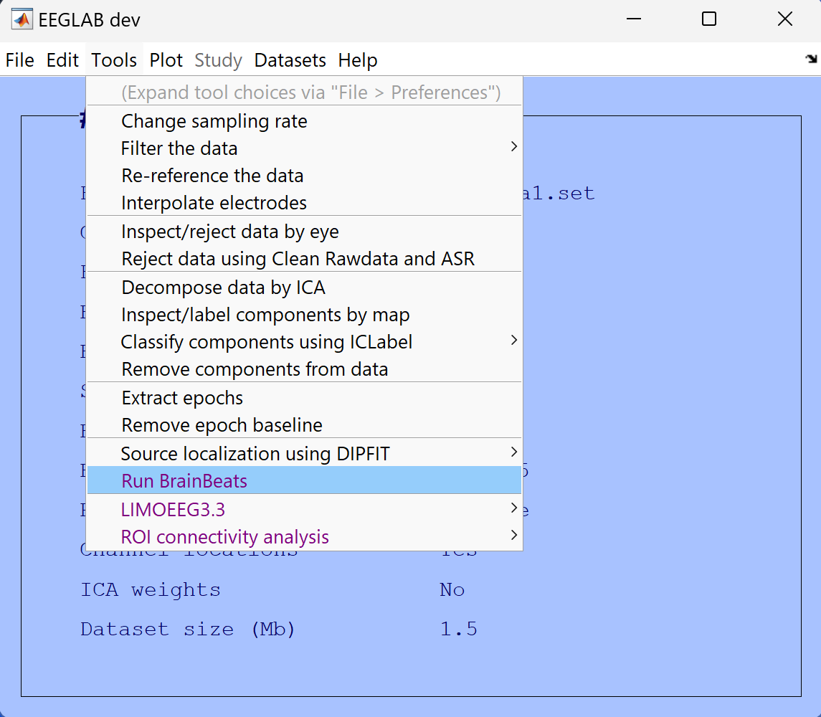

Figure 1.1. Launching the BrainBeats plugin from the mean EEGLAB menu.

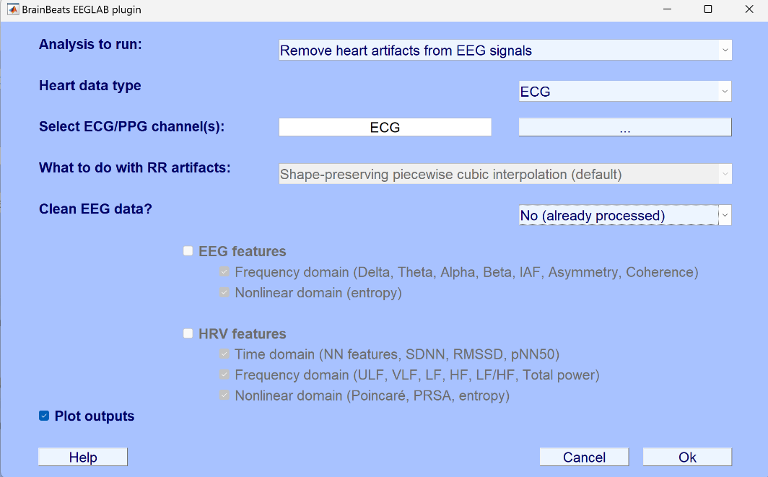

Figure 1.2. Selecting parameters from the general user interface (GUI).

1.3. Independent component analysis (ICA) runs (Infomax algorithm), using PCA reduction is the effective data rank is lower than the number of channels ([Ref](https://www.frontiersin.org/articles/10.3389/frsip.2023.1064138/full?&utm_source=Email_to_authors_&utm_medium=Email&utm_content=T1_11.5e1_author&utm_campaign=Email_publication&field=&journalName=Frontiers_in_Signal_Processing&id=1064138)), and the ICLabel plugin (Ref) is called to automatically detect heart components with at least 95% confidence. Note: the ECG channel(s) is kept, increasing ICA’s source separation performance and chances to separate heart components from the EEG signals, if present. See representative results below.

These steps can be run automatically over many files using the following command lines:

eeglab; close;

dataDir = fileparts(which('pop_BrainBeats.m'));

EEG = pop_loadset('filename','sample_data1.set','filepath',dataDir);

EEG = pop_BrainBeats(EEG,'analysis','rm_heart','heart_signal','ECG','heart_channels', {'ECG'},'vis',true);

1. **Method 2: Heartbeat-evoked potentials (HEP)**

2.1. Load data into EEGLAB: File > Load existing dataset > select “sample_data2.set

2.2. Tools > Run BrainBeats to select the following parameters: Click on “Heartbeat-evoked potentials HEP)” analysis to unlock the other parameters below; select the “EXG5” and “EXG6” ECG channels (click the button to display the list of channels, or type the channel names manually in the text box); You may leave the other default parameters. See overview in **Figure 2.1**.

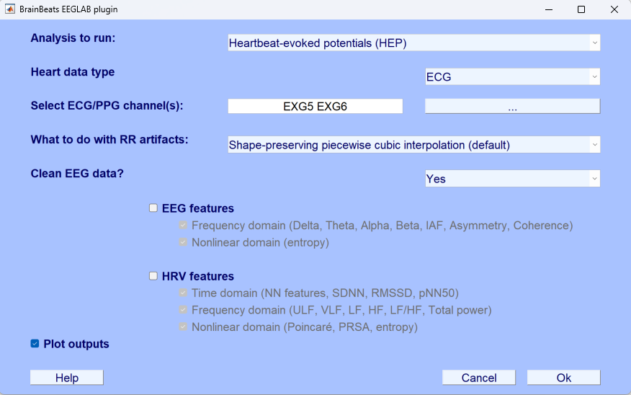

Figure 2.1. Selecting parameters from the GUI for performing heartbeat-evoked potentials (HEP) analysis.

2.3. By default, BrainBeats applies a zero-phase non-causal FIR filter to remove low-frequency drifts and high-frequency noise (high-pass cutoff frequency = 1 Hz, low-pass cutoff = 45; order = 1650; transition bandwidth = 0.5 Hz). If data are not already referenced, BrainBeats re-references the EEG data to infinity/REST (Yao [2001](https://pubmed.ncbi.nlm.nih.gov/11761077/), [200](https://pubmed.ncbi.nlm.nih.gov/15798293/)5; [2017](https://www.ncbi.nlm.nih.gov/pmc/articles/PMC5331115/); [Dong 2017](https://www.ncbi.nlm.nih.gov/pmc/articles/PMC5670162/)) when at least 30 EEG channels are present. Then, BrainBeats uses the *clean_rawdata* plugin to remove bad EEG channels (ignoring the ECG channels; flatlinecriterion = 10; ChannelCriterion = .85; LineNoiseCriterion = 5) and interpolates them using EEGLAB’s spherical splines interpolation (Perrin et al., 1989). When data visualization is ON, the removed channels are plotted (**Figure 2.2.**, in red). CAUTION: These default parameters are implemented for best performance in most cases, but we recommend users to clean their datasets before launching BrainBeats if possible, to adjust parameters depending on their montage, signal quality, etc. For example, abnormal channels may not be reliably detected on low-density EEG montages.

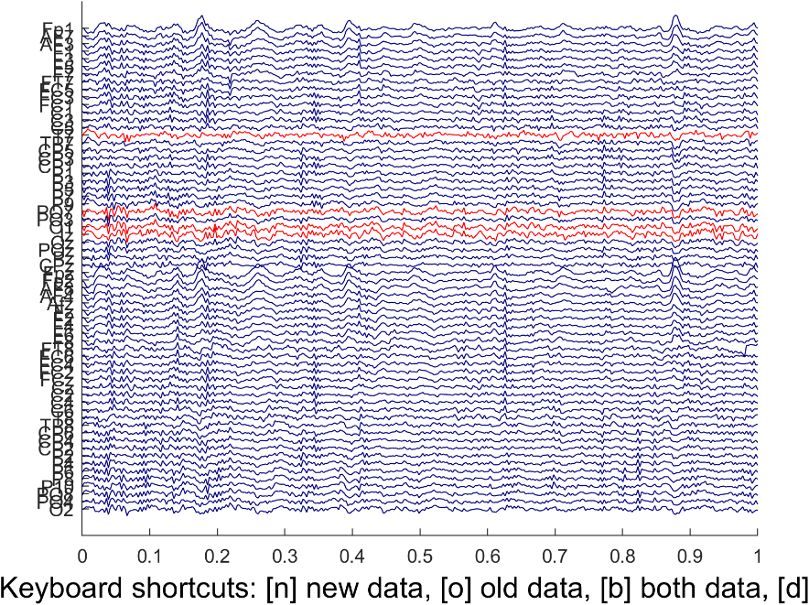

Figure 2.2. Abnormal EEG channels automatically detected and removed by EEGLAB.

2.4. The QRS complexes are detected automatically using the Pan–Tompkins method ([ref](https://ieeexplore.ieee.org/document/4122029)). The energy threshold is estimated at 98-99% of the amplitude of the distribution to better deal with large bumps. A bandpass filter is applied to the ECG signal for best performance. A search back algorithm finds missed peaks by lowering the threshold in an area where the RR interval variability is higher than 1.5 times the median. The algorithm also detects the polarity of the peaks (positive or negative). Refs: Behar et al (2014); Johnson et al. (Year). Users can scroll through the RR intervals to inspect the detected QRS complexes, and the RR artifacts that were interpolated (in red) to obtain the NN intervals (**Figure 2.3.**).

2.5. The signal quality index is calculated using the method developed by Vest et al. in the Physionet Cardiovascular Signal toolbox (Vest et al 2017). When several ECG channels are present, these steps are performed on all of them, and the channel with the best SQI is selected for the following steps.

2.6. RR artifacts are interpolated to obtain NN intervals (default method is the shape-preserving piecewise cubic interpolation).

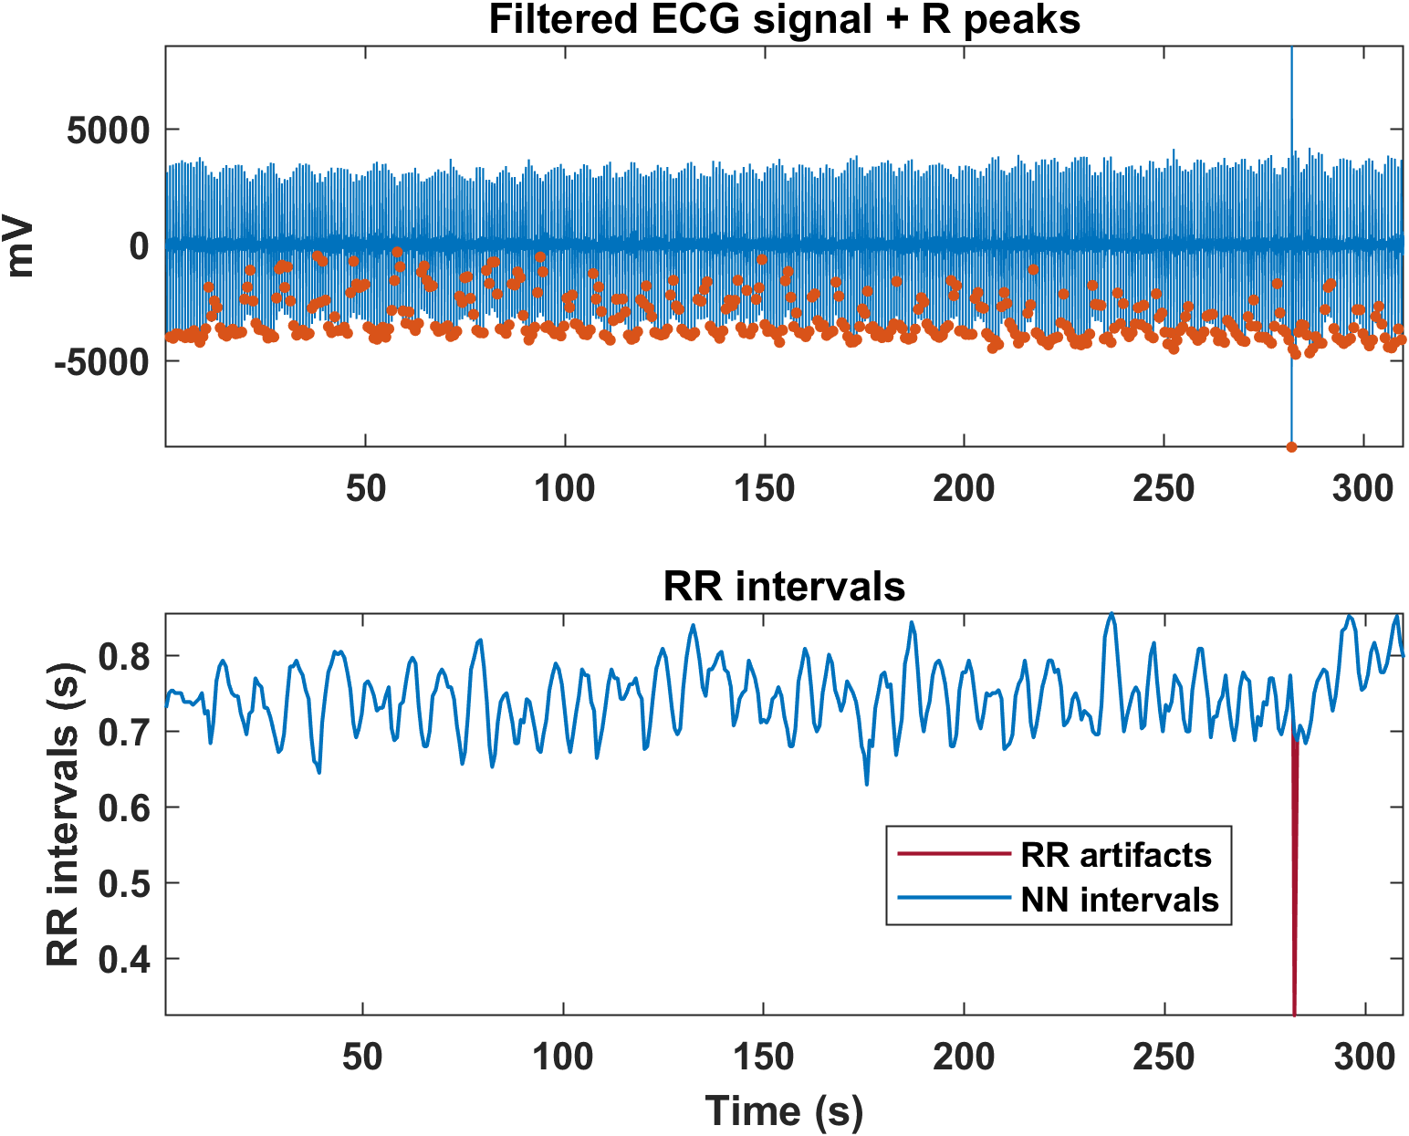

**Figure 2.3**. **Top**: bandpass-filtered ECG time series (blue) and the detected R-peaks (orange dots). A scrolling bar allows users to go through the file in more detail. **Bottom**: Corresponding NN intervals (blue) after the RR artifacts were interpolated (red).

2.7. BrainBeats then marks the R peaks as events in the EEG signals and segments the data using the smallest interval between two R peaks in the series. BrainBeats the root mean square amplitude and a signal-to-noise ratio (SNR) measure for each epoch, and removes bad trials using the *isoutlier* MATLAB function (‘mean’ method for amplitude, and ‘grubbs’ method for SNR). BrainBeats then runs infomax ICA (with PCA dimension-reduction when the data are rank-deficient; Kim et al. 2023) and ICLabel to remove ocular and muscular components with at least 95% confidence (see **Figure 2.4. Top panel**). The final EEG time series, cleaned and epoched around the heartbeats is displayed when “Plot outputs” is set to ON (see **figure 2.4. bottom panel**).

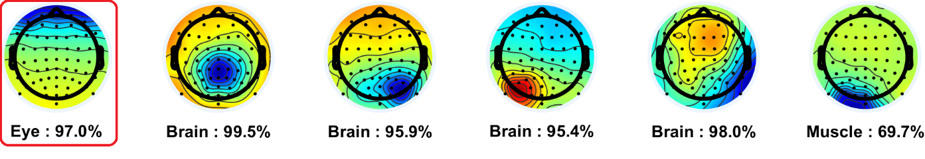

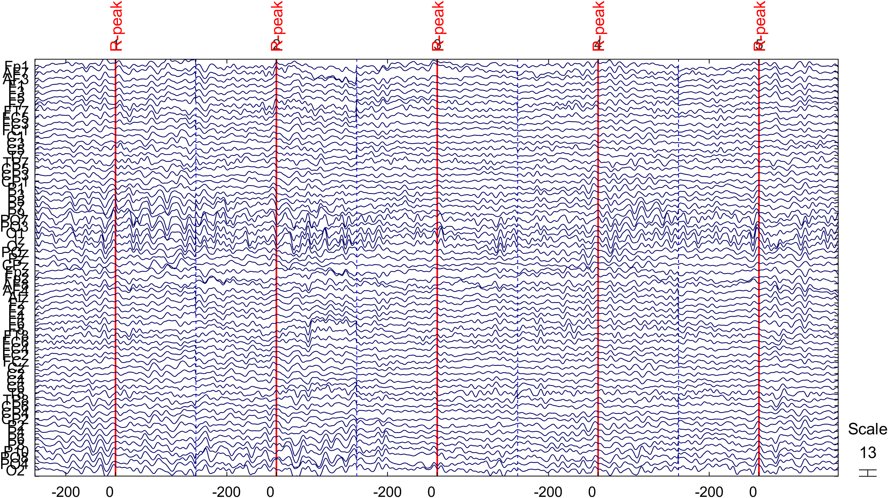

**Figure 2.4. Top**: Ocular component classified by ICLabel. **Bottom**: EEG data segmented around the R peaks after removing bad trials, ocular components with at least 95% confidence.

2.8. The HEP averaged across trials is plotted for all electrodes (Figure 2.5. Top), along with a ERP image (color map) showing the amplitude for over time for the electrode Fcz (Bottom). Note: the period of interest is 200-500 ms (Park and Blanke, 2019; Candia-Rivera et al., 2021). Additionally, another plot displays the average HEP for each individual electrode on topography distribution, allowing users to click on specific ones to examine them more closely (**Figure 2.6.**).

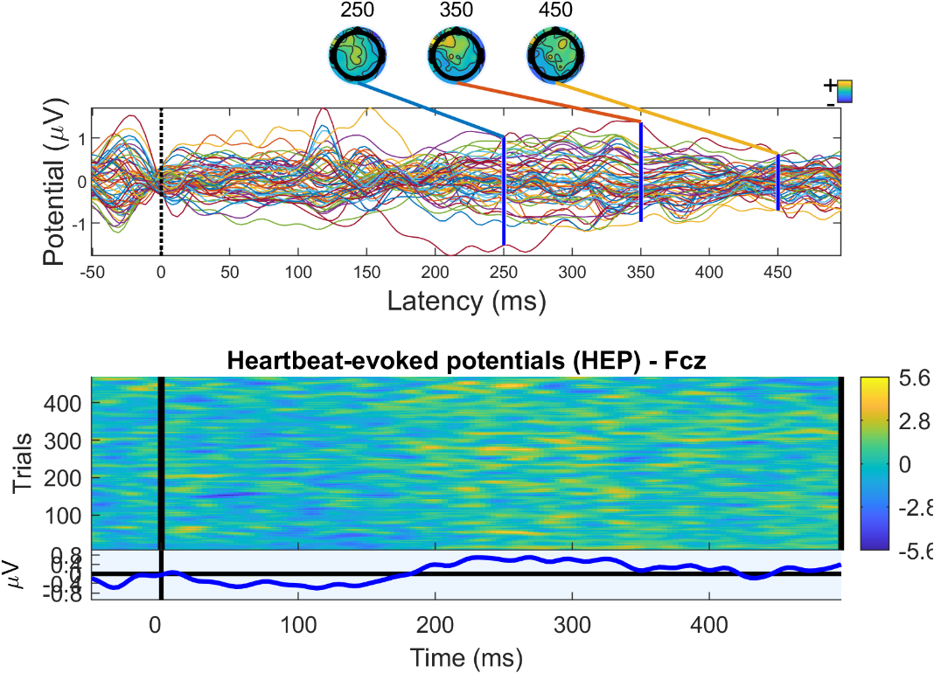

Figure 2.5. Top: Heartbeat-evoked potentials (HEP) averaged across all trials for each electrode, and scalp topography of latencies 250, 350, and 450 ms. Period of interest is 200-500 ms. Bottom: ERP-image of the HEP for electrode Fcz, showing the average (blue line) and all trials (color map).

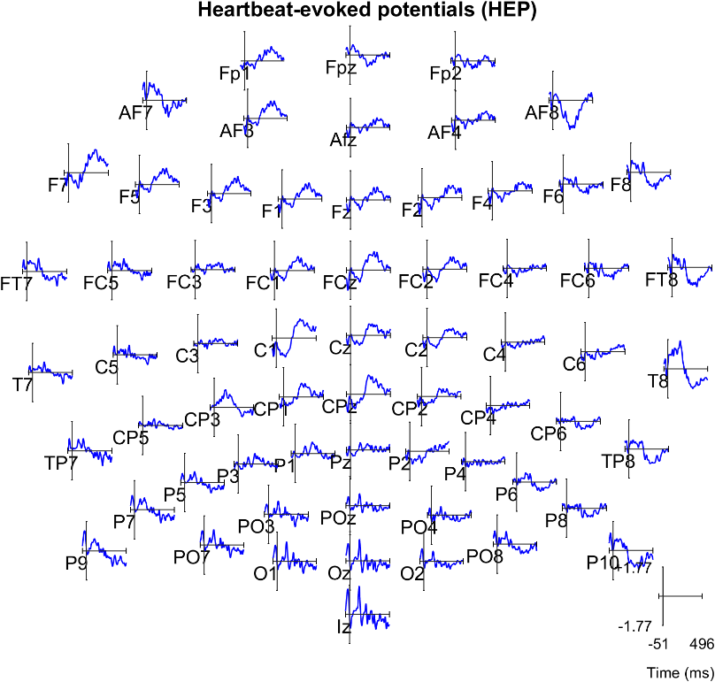

Figure 2.6. Heartbeat-evoked potentials (HEP) for each electrode. Users can click to examine the plots more closely.

2.9. Files are then saved in the same directory and with the same name as the original file with “_HEP” at the end. Note: it is recommended to use a folder for each subject for better organization. Users can pause before processing the next file. When all files are processed .and are later imported into an EEGLAB STUDY to compute ERP and time-frequency decompositions.

2.10. Perform hierarchical linear modeling using the LIMO plugin. A full tutorial is available at <https://github.com/LIMO-EEG-Toolbox/limo_tools/wiki>

Perform all the above steps with the following command line:

eeglab; close;

dataDir = fileparts(which('pop_BrainBeats.m'));

EEG = pop_loadset('filename','sample_data2.set','filepath',fullfile(dataDir, 'sample_data'));

EEG = pop_BrainBeats(EEG,'analysis','hep','heart_signal',{'ECG'}, ...

'heart_channels',{'EXG5' 'EXG6'},'clean_eeg',true,'gpu',true,'vis',true);

**METHOD 3: Feature-based analysis from continuous data**

3.1. Load the same dataset as in METHOD 2 into EEGLAB.

3.2. Select parameters from the GUI (**Figure 3.1.**). Go to Tools > Run BrainBeats > Select “Extract EEG & HRV features from continuous data” > “ECG” > “EXG5 EXG6” > “Yes” to “Clean EEG data?” > Check boxes for all the features > “Ok”.

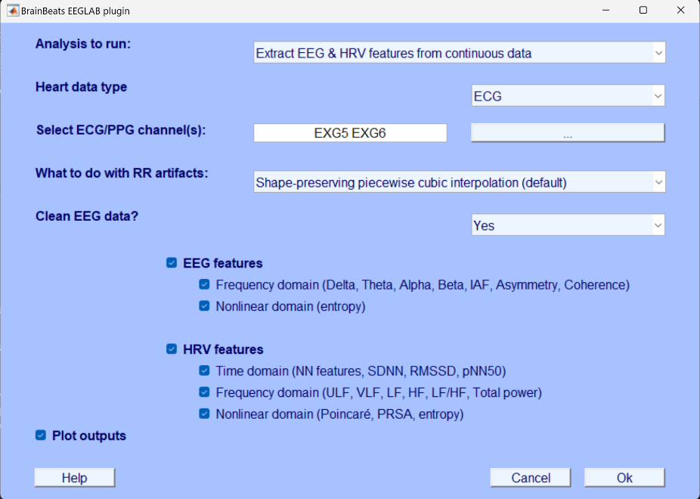

Figure 3.1. GUI to select parameters for extracting HRV and EEG features from continuous data.

3.3. EEG and RR series are cleaned automatically. The same **Figures 2.2.** and **2.3.** pop-up since following the same steps to remove bad EEG channels to obtain the NN intervals on the same the same sample dataset as for METHOD 2. The only difference is that here artifact subspace reconstruction (ASR; SD criterion = 30; REF) is used to remove artifacts from the signals (**Figure 3.2.**), whereas bad trials are removed for HEP analysis. This is because for continuous data, EEG signals do not need to have the exact same time resolution as the ECG signals because features are extracted on these time series separately. However, for HEP analysis, they need to stay time locked.

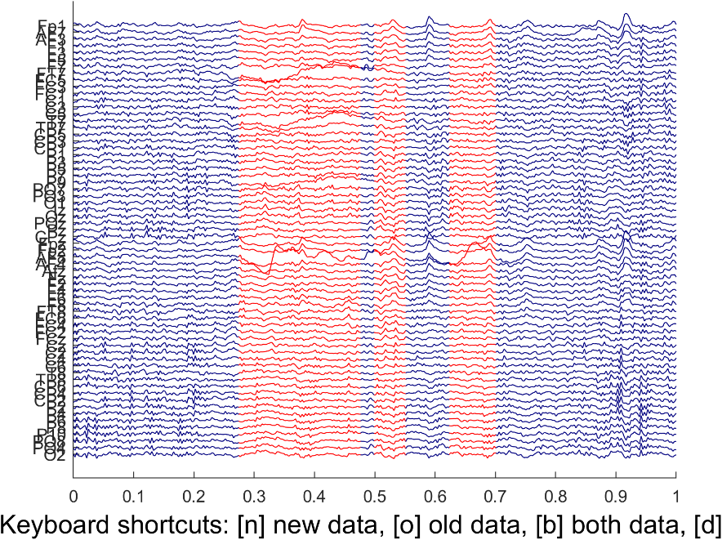

Figure 3.2. EEG artifacts are removed automatically from the continuous EEG data using artifact subspace reconstruction (ASR).

3.4. Then, HRV and EEG features are extracted in the time, frequency, and nonlinear domains. A new plot displays the power spectral density (PSD) and multiscale fuzzy entropy (MFE) estimated on the NN series (**Figure 3.3., Left**), and on the EEG data (the average across all electrodes is used for illustration; **Figure 3.3., Right**). The scalp topography is displayed for each frequency band (**Figure 3.4. top and middle rows**), as well as for the individual alpha frequency (IAF; **Figure 3.4. bottom left**) and fuzzy entropy (**Figure 3.4. bottom right**). **Note**: EEG entropy measures can take a long time to compute. 20 scale factors are set by default, and when EEG signals are longer than 5,000 samples, they are resampled (or decimated when the factor is not an integer) to 90 Hz (i.e., corresponding to a Nyquist frequency of 45 Hz, to match our default low-pass filter). Furthermore, parallel computing is used by default to compute MFE on each scale in parallel and advanced users can activate GPU via the command line to further accelerate the process.

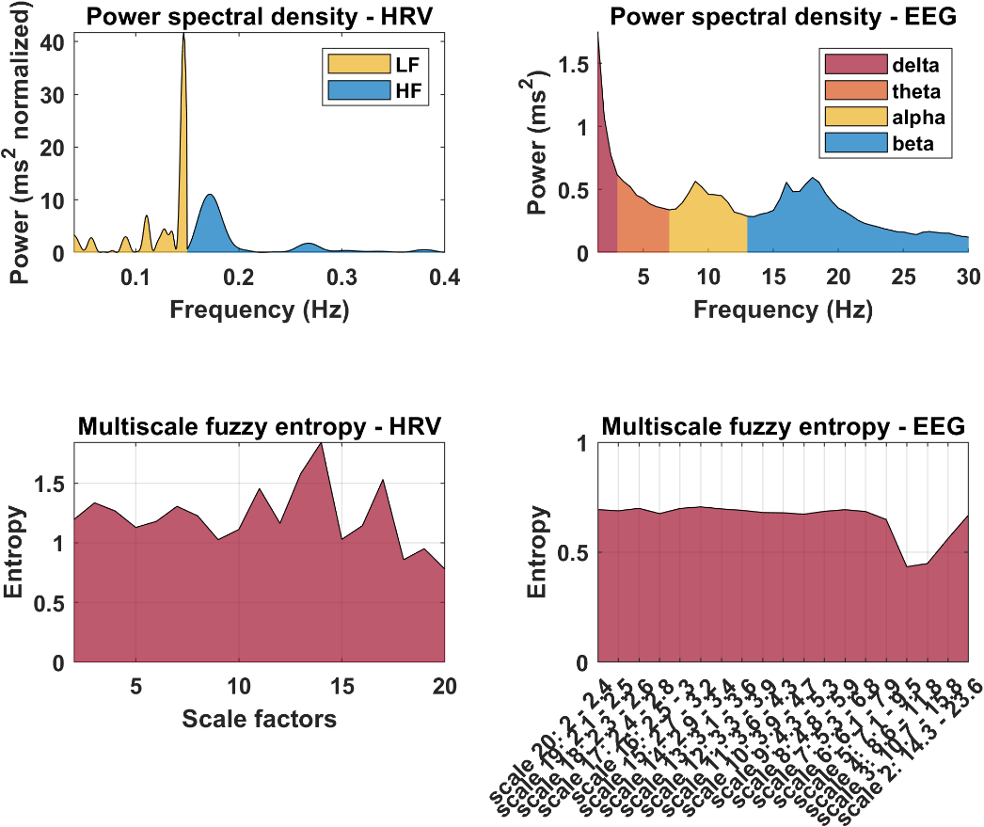

Figure 3.3. Power spectral density (PSD) and multiscale fuzzy entropy (MFE) features estimated from NN intervals (left) and EEG data (right). Note: from sample_data2.set, corresponding of 5 min of mindwandering task, eyes closed.

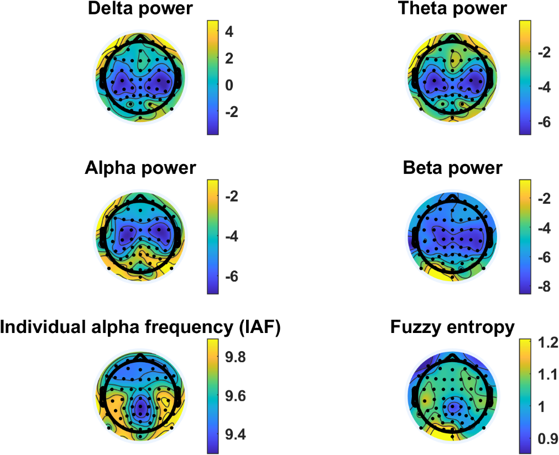

**Figure 3.4.** EEG scalp topographies showing the distribution of mean power spectral density (PSD) for the delta (top left), theta (top right), alpha (middle left), and beta (middle right) frequency bands. The individual alpha frequency (IAF) is plotted in the bottom left corner, and the fuzzy entropy distribution in the bottom right corner. Note: from sample_data2.set, corresponding of 5 min of mindwandering task, eyes closed.

Advanced users can perfom all steps above with the following command:

EEG = pop_loadset('filename','sample_data2.set','filepath',fullfile(dataDir,'sample_data'));

[EEG, Features] = brainbeats_process(EEG,'analysis','features','heart_signal','ECG', ...

'heart_channels',{'EXG5' 'EXG6'}, 'clean_eeg',true, ...

'eeg_features', {'frequency' 'nonlinear'}, ...

'hrv_features', {'time' 'frequency' 'nonlinear'}, ...

'gpu',false,'parpool',true,'vis',true);

**REPRESENTATIVE RESULTS:**

**METHOD 1**

When no heart components are detected, users are informed in MATLAB’s command window, and the program ends. If at least one heart component is detected, its scalp topography and confidence level are displayed in a figure (**Figure 3 Left**). Click on the red button to visualize the heart component’s detailed properties (**Figure 3 Middle**). Click “Ok” or exit buttons when done with visualization. The ECG channel is then removed from the dataset and the heart component is extracted from the EEG signals automatically. The difference between before and after heart component removal is displayed automatically (**Figure 3 Right**). Note: All figures are only created when the “Plot outputs” box is checked in the GUI).

Figure 3. Left: Scalp topography and confidence level of the heart component that was detected by ICLabel. Middle: Detailed properties of the component can be visualized by clicking on the red button on the Left. Right: Difference between before and after removal of the heart component from EEG signals. The ECG channel is then removed from the dataset.

METHOD 2

**FIGURE AND TABLE LEGENDS:** Text: Use Calibri, 20 pt. font or greater.

* All figures should be provided as individual files. DO NOT embed them in the manuscript file.
* All microscopic images must include scale bars.
* All data figures must include measurement definitions and error bars (if applicable). Please define all error bars (SEM, SD, Range, *etc*.).
* Axis/Axis Tick Labels/Graph Lines: Use 20 pt. size font or greater, 3 pt. line weight or greater.
* A multi-panel figures (with parts A, B, C, *etc*.) should be submitted as a single, combined image file that contains all parts of the figure.
  + Preferred figure file types: .eps, .psd, .pdf. Please save any .ai files as a .pdf for submission but maintain .ai files for production purposes.
  + .tiff, and .jpg (not preferred) files must be at least 1,440 pixels x 480 pixels, or 300 dpi.
  + Preferred animated figure file types: .mov, .mp4, .m4v (upload as “Animated/Video Figure”).
  + 50 MB maximum size (Contact your editor or [submissions@jove.com](mailto:submissions@jove.com) for exceptions).
  + All tables should be provided as individual .xls or .xlsx files and submitted as Tables.

**TABLE OF MATERIALS:** A Table of Materials is required for all articles. A template is provided [here](http://www.jove.com/files/templates/JoVE_Materials.xls). Please do not number the Table of Materials in the article. Please do not include any ™/®/© symbols here.

**FIGURE AND TABLE LEGENDS:**Each figure or table, including supplemental figures/tables, must have an accompanying legend comprised of a short title and a short description of each panel or a general description. Legends should be included as part of the manuscript and not included in the figure file.

Example: **Figure 1:** **Representative flow cytometry analysis of non-permeabilized cells**. **A**. Schematic representation of gating strategy used in flow cytometry analysis sample. Data were analyzed after acquisition with the appropriate software… **B**.Semi-log graph for the….

Enter text here.

**DISCUSSION:** *(3-6 paragraphs)*

JoVE is a methods-based journal. Thus, the Discussion section of the article should be focused on the protocol and not the representative results. This section should discuss the following with citations:

Critical steps in the protocol

The order of the critical steps to ensure correct use of the three methods is facilitated by the structure of the toolbox. The most critical step is the selection of parameters (for processing and statistics). Most crucial parameters (that would greatly affect outputs) can only be modified by advanced users through the command line, which should limit the use of aberrant parameters by novice users.

Modifications and troubleshooting of the method

The toolbox will continue to be modified and improved by the authors, to implement latest guidelines and recommendations by experts in the field, and fixing any errors and or issues that may arise.

Limitations of the method

Entropy features are particularly promising for capturing complex, bidirectional interactions between cardiovascular, subcortical, and cortical systems that may be hidden in nonlinear feedback loop dynamics (Costa et al., 2005). However, they are very computational heavy and can take very long times to compute on EEG signals. While improvements were made (parallel computing, GPU computing, signal downsampling/decimation), further accelerations are needed.

* The significance of the method with respect to existing/alternative methods

The first method allows quick and easy removal of heart components from the EEG signals, in an automated manner. While this was possible before, it required various steps, such as highpass filtering the signals, running ICA, running ICLabel, tuning parameters, subtracting the heart components from the EEG signals, and removing the ECG channels.

* Future applications or directions of the method

Brain-heart interactions:

https://www.mathworks.com/matlabcentral/fileexchange/72704-brain-heart-interaction-indexes

Random forest binary classification of 2 classes of patients HEP data:

https://github.com/diegocandiar/brain_heart_doc

**ACKNOWLEDGMENTS:** Please list acknowledgments and all funding sources for the work here. Also consider listing any person appearing in the film who does not appear in the authors list.

Add the Time-Resolved Directional Brain-Heart Interplay Measurement Through Synthetic Data Generation Models: <https://pubmed.ncbi.nlm.nih.gov/30989444/>

**DISCLOSURES:** The corresponding author must ensure that all authors have disclosed any and all conflicts of interest. Examples of a conflict of interest would be “The author [full name] is an [employee/shareholder, *etc.*] of [full company name] that produces reagents and/or instruments used in this Article”. If authors have no conflict of interest, a statement stating this must be included. The default text is “The authors have nothing to disclose.”

Enter text here.

**REFERENCES:** *(10 minimum; if using EndNote, please use the* [*JoVE EndNote style file*](http://www.jove.com/files/JoVE.ens)*)*

In-Text Formatting:

* The corresponding reference numbers should appear as superscripts after the appropriate statement(s) in the text (before punctuation but after closed parenthesis). The references should be numbered in order of appearance.
* Multiple references should be separated by commas, or a dash for inclusive numbers: example2,5 refers to references 2 and 5, while example2-5 refers to references 2 through 5.
* Personal communications, unpublished data, and conference abstracts can be cited parenthetically in the text with author last name, initials, and year.
* Footnotes should not be used. Grant details and personal acknowledgments should not be cited as a numbered reference (but included in the Acknowledgments section).

*Citation Formatting:* (in order)

* Last name, first and middle initials (if available). List ALL authors. If there are six or more authors, list the first author and then “*et al.”*.
* Include article, book, or chapter titles. Titles of books should be italicized, whereas article and chapter titles should not.
* Article titles should start with capital letters and end with periods, and should appear exactly as they were published in the original work with no abbreviations or truncations.
* Write journal names in italics. The city or country where a journal is located can be included in parenthesis with the journal name. For books or other works, a publisher name, city, and country can be included.
* Write volume numbers in bold, followed by a space, issue number (in parentheses), a comma, and then a range of page numbers (start page – last page). A single page number or digital object identifier [doi] can be substituted for a range of page numbers.
* Provide the year published (in parentheses), followed by a period.
* “Accepted” or “In Press” can be listed after the title or journal name and before the year. Manuscripts that are in preparation or under review should not be listed.

*Citation Examples:*

Bedford, C.D., Harris, R.N., Howd, R.A., Goff, D.A., Koolpe, G.A. Quaternary salts of 2-[(hydroxyimino)methyl]imidazole. *Journal of Medicinal Chemistry*. **32** (2), 493-503 (1998).

Kioh, L.G. *et al.* *Physical Treatment in Psychiatry*. Blackwell Scientific Pubs. Boston (1988).

von Bertalanffy, L. (1968). General system theory: Foundations, development, applications. George Braziller.

Bunge, M. (2003). Emergence and convergence: Qualitative novelty and the unity of knowledge. University of Toronto Press.

Fuchs, T. (2018). Ecology of the brain: The phenomenology and biology of the embodied mind. Oxford University Press.

Thayer, J. F., & Lane, R. D. (2009). Claude Bernard and the heart-brain connection: Further elaboration of a model of neurovisceral integration. Neuroscience and Biobehavioral Reviews, 33(2), 81-88.

Insel, T. R., Landis, S. C., & Collins, F. S. (2017). Research priorities. The NIH BRAIN Initiative. Science, 340(6133), 687-688.

Kappenman, E. S., & Luck, S. J. (Eds.). (2010). The Oxford handbook of event-related potential components. Oxford University Press.

Costa, M., Goldberger, A. L., & Peng, C. K. (2005). Multiscale entropy analysis of complex physiologic time series. Physical Review Letters, 89(6), 068102.

Kemp, A. H., Quintana, D. S., Gray, M. A., Felmingham, K. L., Brown, K., & Gatt, J. M. (2010). Impact of depression and antidepressant treatment on heart rate variability: A review and meta-analysis. Biological Psychiatry, 67(11), 1067-1074.

Lehrer, P., Gevirtz, R., & Eddie, D. (2021). Heart rate variability biofeedback: A theoretical perspective and review of its effectiveness for

Bean, B. P., Cohen, C. J., & Tsien, R. W. (1984). Lidocaine block of cardiac sodium channels. The Journal of General Physiology, 73(6), 679-696.

Thayer, J. F., Åhs, F., Fredrikson, M., Sollers III, J. J., & Wager, T. D. (2012). A meta-analysis of heart rate variability and neuroimaging studies: Implications for heart rate variability as a marker of stress and health. Neuroscience & Biobehavioral Reviews, 36(2), 747-756.

Mather, M., & Thayer, J. F. (2018). How heart rate variability affects emotion regulation brain networks. Current Opinion in Behavioral Sciences, 19, 98-104.

Kemp, A. H., & Quintana, D. S. (2013). The relationship between mental and physical health: Insights from the study of heart rate variability. International Journal of Psychophysiology, 89(3), 288-296.

Jiang, H., He, B., Guo, X., Wang, X., Guo, M., Wang, Z., ... & Cui, D. (2020). Brain–Heart interactions underlying traditional Tibetan Buddhist meditation. *Cerebral Cortex*, *30*(2), 439-450.

Schandry, R. (1981). Heart beat perception and emotional experience. Psychophysiology, 18(4), 483-488.

Pollatos, O., Kirsch, W., & Schandry, R. (2005). Brain structures involved in interoceptive awareness and cardioafferent signal processing: a dipole source localization study. Human Brain Mapping, 26(1), 54-64.

Montoya, P., Schandry, R., & Müller, A. (1993). Heartbeat evoked potentials (HEP): topography and influence of cardiac awareness and focus of attention. Electroencephalography and Clinical Neurophysiology, 88(2), 163-172.

Park, H. D., & Tallon-Baudry, C. (2014). The neural subjective frame: from bodily signals to perceptual consciousness. Philosophical Transactions of the Royal Society B: Biological Sciences, 369(1641), 20130208.

Couto, B., Adolfi, F., Sedeño, L., Salles, A., Canales-Johnson, A., Alvarez-Abut, P., ... & Ibanez, A. (2015). Disentangling interoception: insights from focal strokes affecting the perception of external and internal milieus. Frontiers in Psychology, 6, 503.